1. Practice Code of Multiplication and print the Product  
   Code:

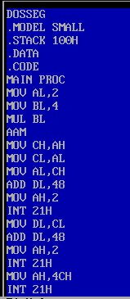



Result:



1. Program to print A to Z in capital letters using loop

Code:

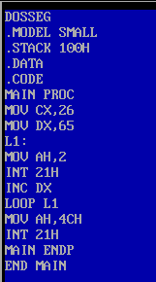

Result:



1. Program to input a capital letter from user and convert it into small letter (uppercase to lowercase)

Code:

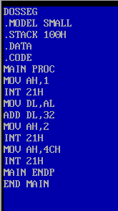

Result:  


4. Program to input String from user and print its length

Code:

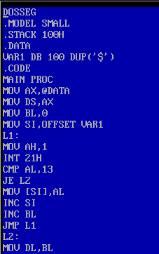

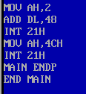

Result:

